MONDAY Flashbacks:
- Theme (RL.7.2) – Which would most likely be the topic of a story with the theme, “Don’t judge a book by its cover”?
- A young girl falling in love
- An old homeless man who is an honored war veteran
- A young man obtaining his dream profession on his favorite football team
- A lost kitting finding an adopted family
- Plotline (RL.7.3) – In a story where a young boy has to decide between helping himself or helping a friend, the type of conflict is:
- Character vs. Character
- Character vs. Nature
- Character vs. Society
- Character vs. Self
- Figurative Lang (RL/RI.7.4) – Select the type of FL being used: The lady was so old and wrinkled, she was a sea of dunes in the desert.
- Simile
- Idiom
- Metaphor
- Personification
- Vocabulary (RL/RI.7.4) – Select which sentences uses the word “concise” correctly?
- The batter was so concise he hit a foul ball into the skybox.
- Although the lecture was lengthy and covered some irrelevant information, the speaker was concise.
- The teacher’s instructions for the assignment were concise, so it was easy to understand what we are supposed to do.
- Bobby’s feelings were hurt when Mary was concise about his performance in the play.

TUESDAY Flashbacks:
- Theme (RL.7.2) – The difference between a theme and a theme statement is:
- Theme is usually summed up in very few words while a theme statement represents an entire idea.
- Theme is a summary of an entire story where the theme statements summarizes the main idea of the text.
- Theme identifies the type of conflict experienced between characters where a theme statement details the events leading up to and resolving the conflict.
- Theme is the author’s views on the topic where the theme statement generalizes these views for a broader interpretation.
- Plotline (RL.7.3) – The correct order of a plotline is:
- Denotation -> Rising Action -> Climax -> Falling Action -> Exposition
- Exposition -> Climax -> Conflict -> Falling Action -> Resolution
- Introduction -> Rising Action -> Climax -> Falling Action -> Resolution
- Introduction -> Rising Action -> Conflict -> Falling Action -> Resolution
- Figurative Lang (RL/RI.7.4) – Select the type of FL being used: She sells seashells down by the seashore.
- Onomatopoeia
- Personification
- Repetition
- Alliteration
- Vocabulary (RL/RI.7.4) – The word “acknowledge” most closely means:
- to lie
- to do well
- to admit
- to be overwhelmed
WEDNESDAY Flashbacks:
- Theme (RL.7.2) – Which of the following is an appropriate support to provide reason why “Games” is an applicable theme for the book “Ender’s Game”?
- Ender was able to learn real-life skills by using game simulations to train.
- Ender was able to learn how the hive-queen communicated by playing the Mind Game and beating the Giant.
- Peter use to play board games with Ender when he was younger.
- Graff taught Ender how to play the holographic game simulator at Command School.
- Plotline (RL.7.3) – What is the climax of a story?
- The beginning of the story where all events are leading up to a main event in the story.
- The end of the story where you learn what will happen in the future or be left in suspense.
- The most exciting part of a story where the main conflict is resolved.
- The beginning of the story where the reader is introduced to the background leading up to the current events in the story.
- Figurative Lang (RL/RI.7.4) – Select the type of FL being used: As she climbed up on papa’s lap, her eyes were as big as saucers as he told the tale of the Hash-Slinging Slasher.

- Hyperbole
- Simile
- Metaphor
- Alliteration

- Vocabulary (RL/RI.7.4) – Which sentence uses the word “antidote” correctly?
- The old chief told an antidote about the two skins of the coyote while we were all gathered around the fire.
- We were fortunate the old chief knew the antidote to the snake bite, or Sam would have surely died.
- As we talked into the night around the fire, the antidotes glistened in the sky.
- It would be a long time before Sarah would use that antidote to tame a coyote again.

THURSDAY Flashbacks:
- Theme (RL.7.2) – Identify a possible theme statement for the following passage: All Victor ever wanted to do with his life was be a singer. He didn't pay attention in school and he spent all of his time at home watching music videos online and impersonating his idols. His mother tried to teach him the value of getting an education and having a backup plan, but Victor would respond the same way every time, "Mom, I won't need to know any of that boring old stuff when I'm famous. You'll see." But there was one major problem with Victor's plan: he wasn't any good at singing. Victor wanted to be a singer so badly, that he didn't notice the pained look on the faces of those who endured his singing. Because he wanted to be a singer so badly, when honest people told him to find something else to do with his life, he accused them of being "jealous haters" and ignored their advice. After Victor dropped out of high school to focus on his music career, the years passed and the doors never opened.

- Don’t judge a book by its.
- Always have a back-up plan.
- Treat others the way you would want to be treated.
- Always look on the bright side of life.

- Plotline (RL.7.3) – What elements are included in the exposition of a plot diagram?

- Introduction, Climax, Resolution
- Setting, Situation, Characters
- Characters, Conflict, Climax
- Rising Action, Conflict, Falling Action

- Figurative Lang (RL/RI.7.4) – Select the type of FL being used: Lollie was amazed when she saw how big the cabin was they would be staying in; it was a million times better than any old tent.

- Metaphor
- Alliteration
- Idiom
- Hyperbole

- Vocabulary (RL/RI.7.4) – The word “morale” can be defined as:

- a bad attitude
- the confidence and enthusiasm of a group
- strong moral principles
- merciful

FRIDAY Flashbacks:
- Figurative Lang (RL/RI.7.4) – Select the type of FL being used: When Billy picked up Sally for their date, he exclaimed, “You are as beautiful as Marylyn Monroe!”
- Onomatopoeia
- Personification
- Alliteration
- Allusion
- Vocabulary (RL/RI.7.4) – Which sentences uses the word “reinforce” correctly?
- The artist wanted to reinforce the color so he diluted it with mineral water.
- Papaw had to put salt on the driveway to reinforce the snow.
- The king ordered another barrier be placed against the gate to reinforce their defense.
- The baby bird took to the sky, allowing the air to reinforce its wings.
- Structure (RL/RI.7.5) – What are the groups of text in poetry called?
- Paragraphs
- Stanzas
- Chapters
- Scenes
- Point of View (RL/RI.7.6) – What point of view is expressed when the narrator is retelling a story that happened to them?
- 1st Person
- 2nd Person
- 3rd Person
- Omnipotent Narration

Name:______________________ Date:__________ Period:_____
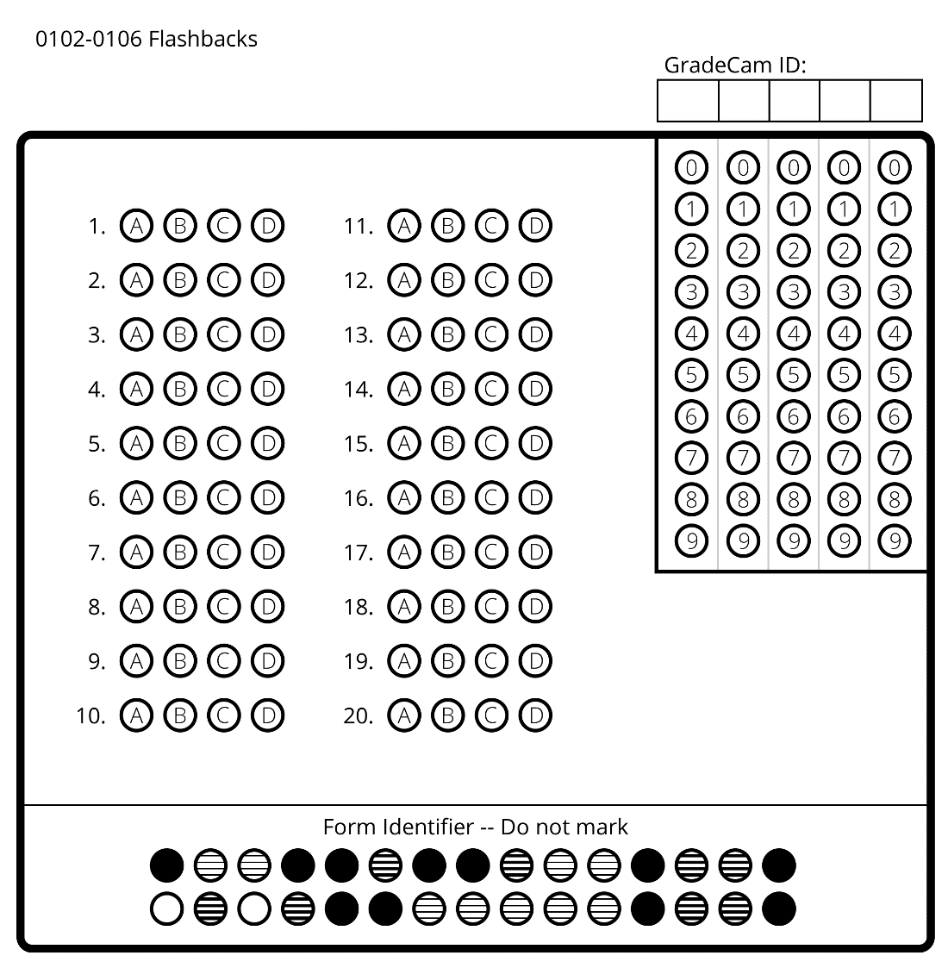

Name:______________________ Date:__________ Period:_____

Flashbacks 0102-0106 (Key)
- B
- D
- C
- C
- A
- C
- D
- C
- A
- C
- B
- B
- B
- B
- D
- B
- D
- C
- B
- A

